MUSIC RHYTHMS IN A COVID-19 AGE…
Here is a FUN, rhythm activity using the terminology of the COVID-19 virus where students can create their own rhythm compositions! Students and parents can create/say/clap the patterns which will reinforce musical concepts such as beat and rhythm (terminology – quarter note; ta/eighth notes; ti-ti/ half note; ta-ah/sixteenth notes; ticka-ticka/whole note; ta-a-a-a). Enjoy this activity which will hopefully bring a little levity to these trying times.
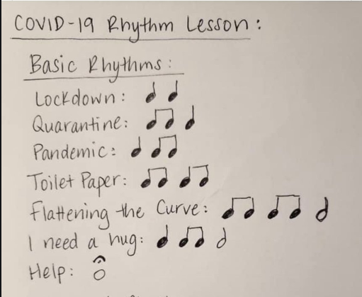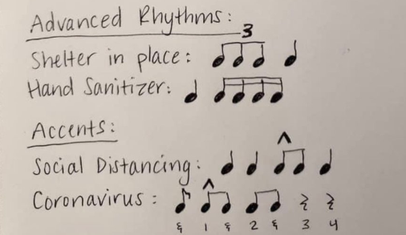*Place 2 words (lockdown/quarantine/pandemic/toilet paper) in each box OR 1 phrase to create a 4 beat pattern.*
4
4

4
4

4
4

